***Project Description – Hangman Game***

**Introduction**

The Hangman Game is a classic word-guessing game where the player tries to guess a hidden word by suggesting letters within a limited number of attempts. This project is implemented in **Python** and uses fundamental programming concepts such as loops, conditionals, functions, and data structures. The aim of building this project was to practice Python skills, understand control flow, and apply logical thinking in a fun and interactive way.

**Approach**

**How the Game Works**

1. The program randomly selects a word from a predefined word list.
2. The chosen word is hidden with underscores (_) representing each letter.
3. The player guesses one letter at a time.
   1. If the letter exists in the word, it is revealed in the correct positions.
   2. If not, the number of remaining attempts decreases.
4. The game continues until:
   1. The player successfully guesses the word (Win).
   2. The player runs out of attempts (Lose)

**Why This Approach**

* **Random module** is used to make the game unpredictable and engaging.
* **Loops and conditions** allow checking each guess dynamically.
* **Lists and strings** are used for easy manipulation of letters and word display.
* **Stages of Hangman** visually represent the player’s progress, making the game more interactive

**Output Screenshot**

The screenshot of Outputs are given below

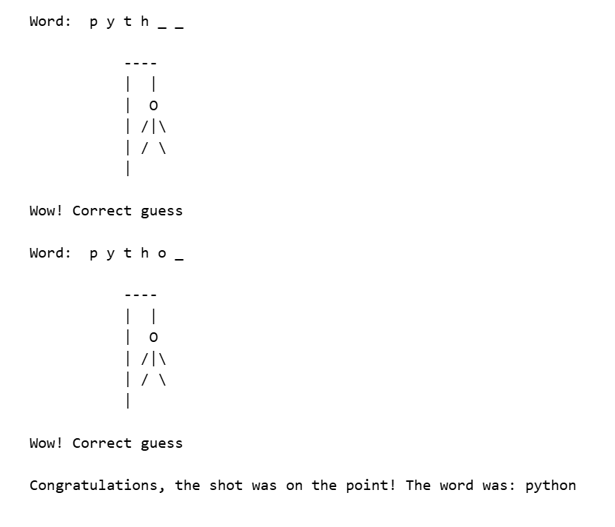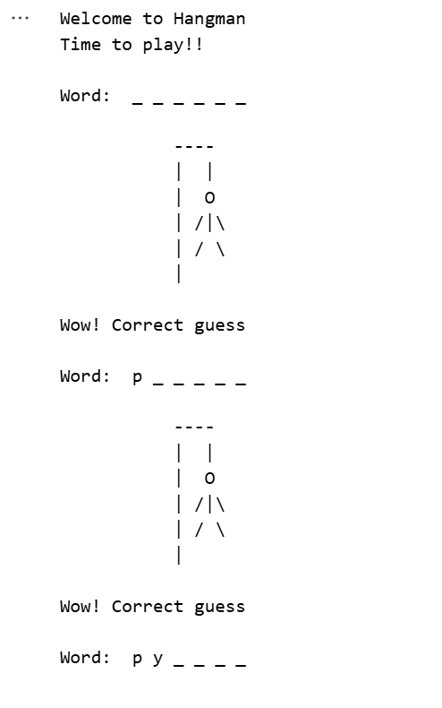

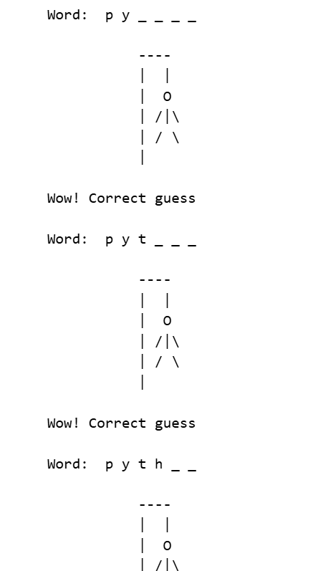

**Conclusion**

The Hangman Game project was a practical way to learn and implement Python programming concepts. It shows how logic, randomization, and data structures can be combined to create an interactive game. This project not only strengthens programming fundamentals but also introduces the idea of **game design** and **user interaction in console-based applications**